System Requirements:

1. The system should allow users to create an account.
2. Each account should have a username, birth date, location, posts (if exists), follower accounts (if exists), and following accounts (if exists).
3. The system should allow users to follow and unfollow other users.
4. The system should only allow users to send messages to users they are following.
5. The system should have an inbox and outbox for each account to store sent and received messages.
6. Each account should be able to post content.
7. Posts should be able to receive interactions, which have subclasses like and comment.
8. The system should allow users to login and logout, and only one user should be able to be logged in at a time.
9. The system should allow users to block other users.When a block happens,both sides should be unavailable to view each others profile,posts nor send each other messages.
10. The system should allow users to see other people’s posts and see the interactions of the posts.

Problem Solution Approach:

* 1. Create the classes based on the ER Diagram.
  2. Create related functions and variables for one-sided operations
  3. Create related functions and variables for two-sided operations
  4. Implement the functions
  5. Test the given test classes
  6. Conclusion

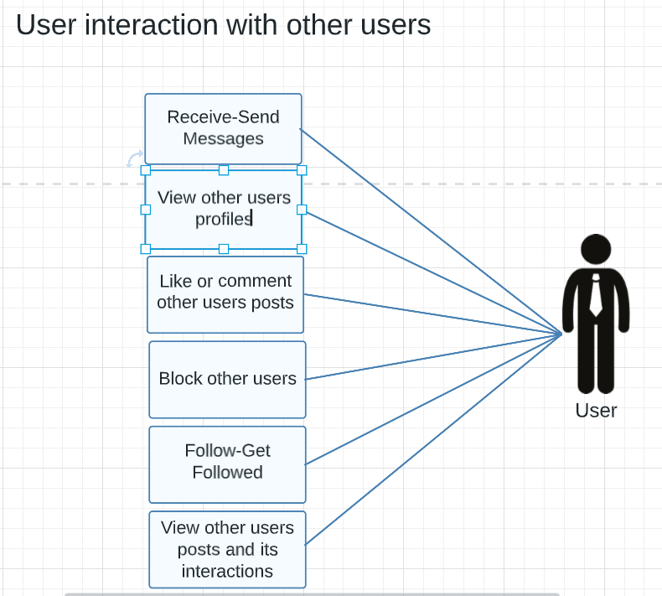

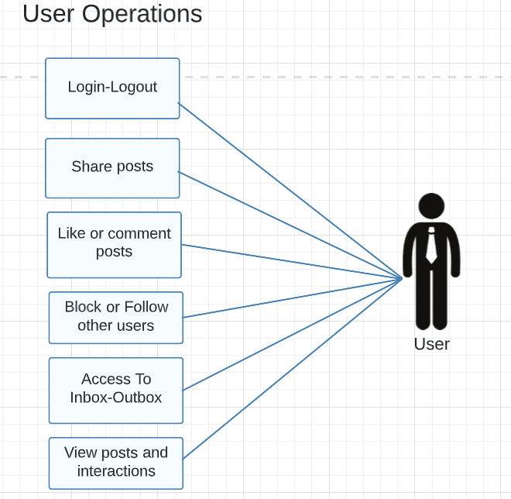

Test Cases 1

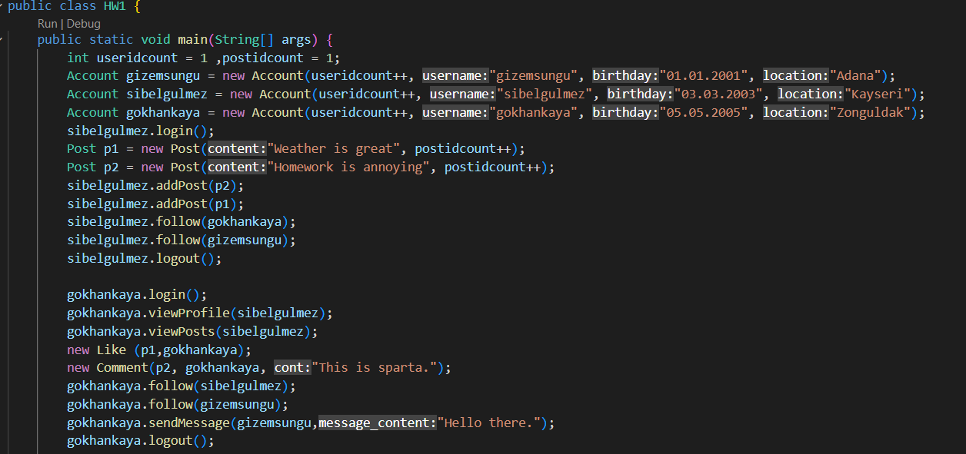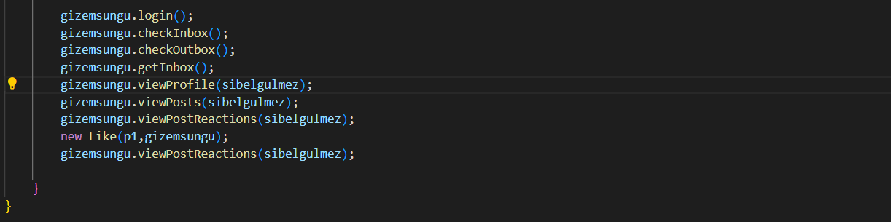

Result 1 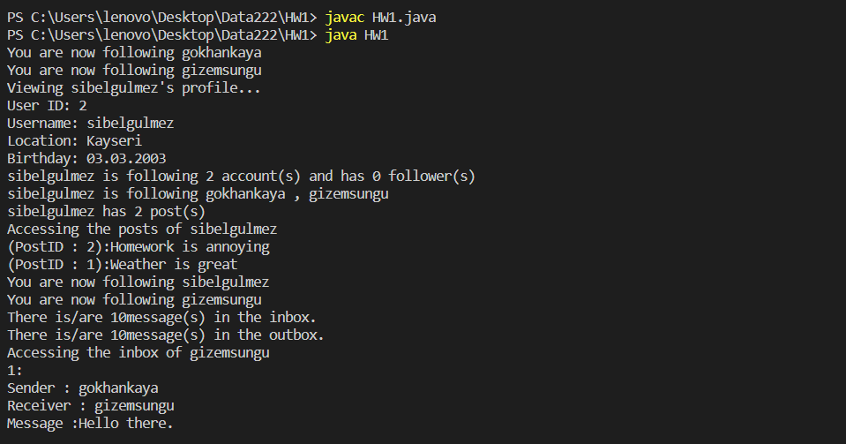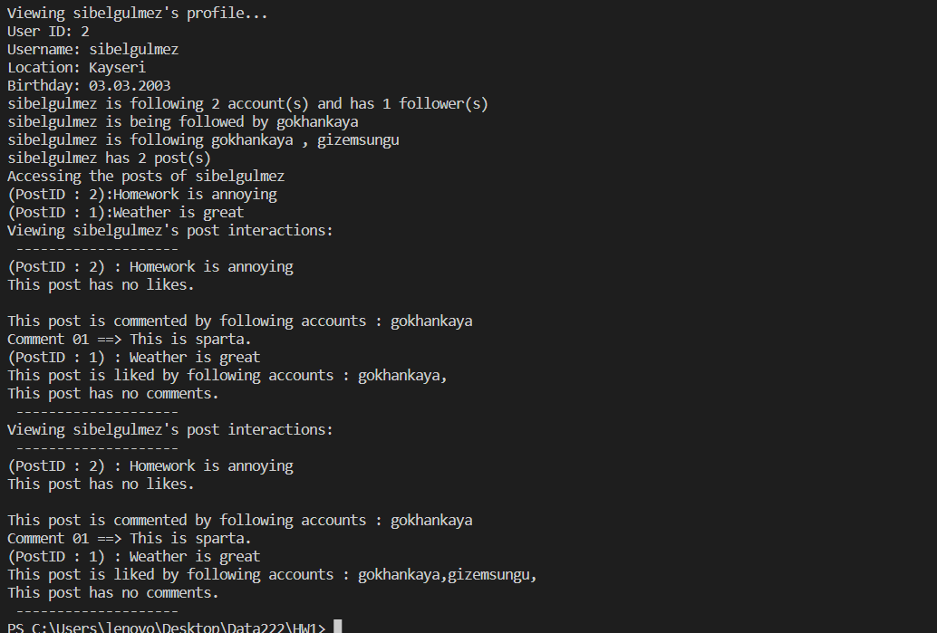

Test Case 2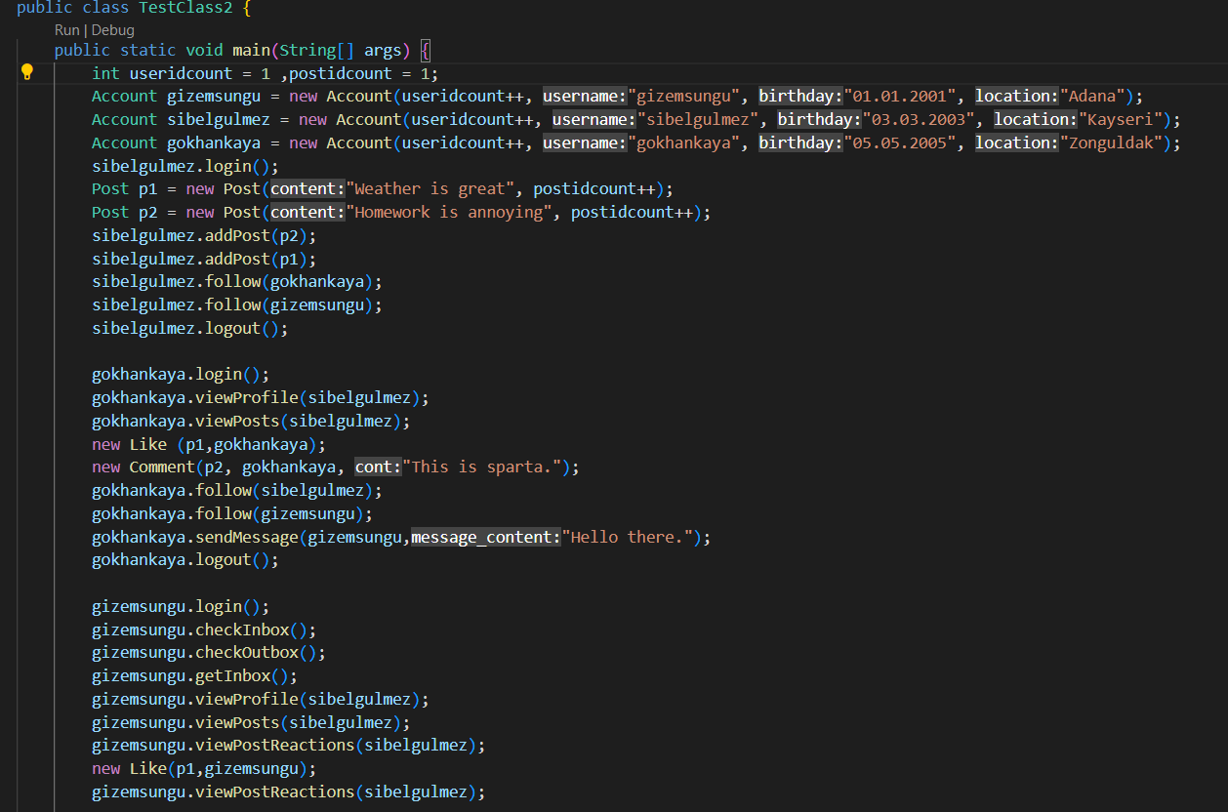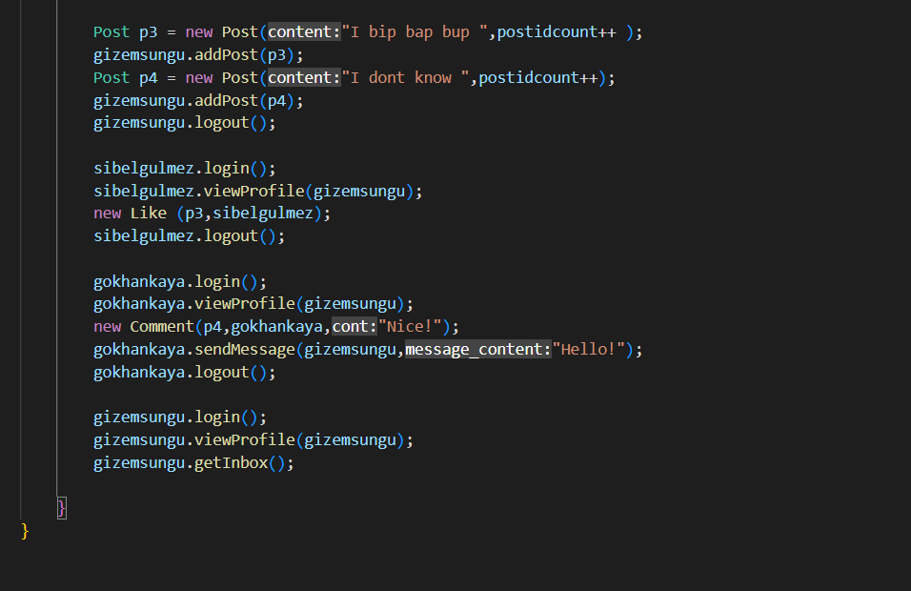

Result 2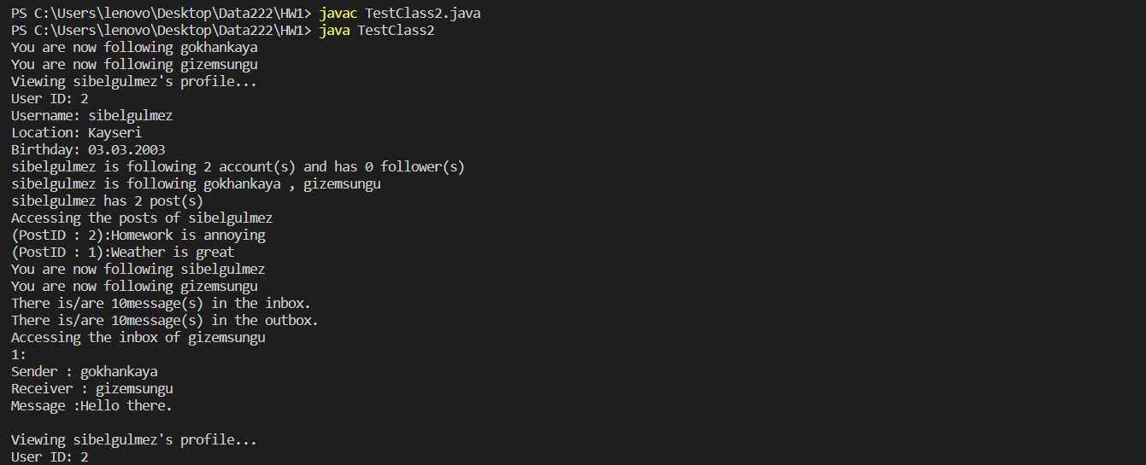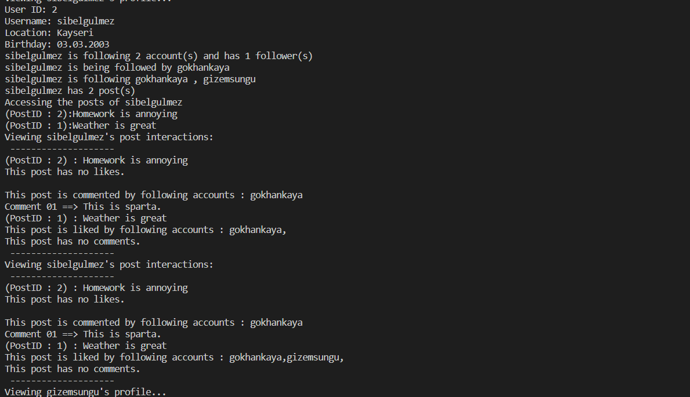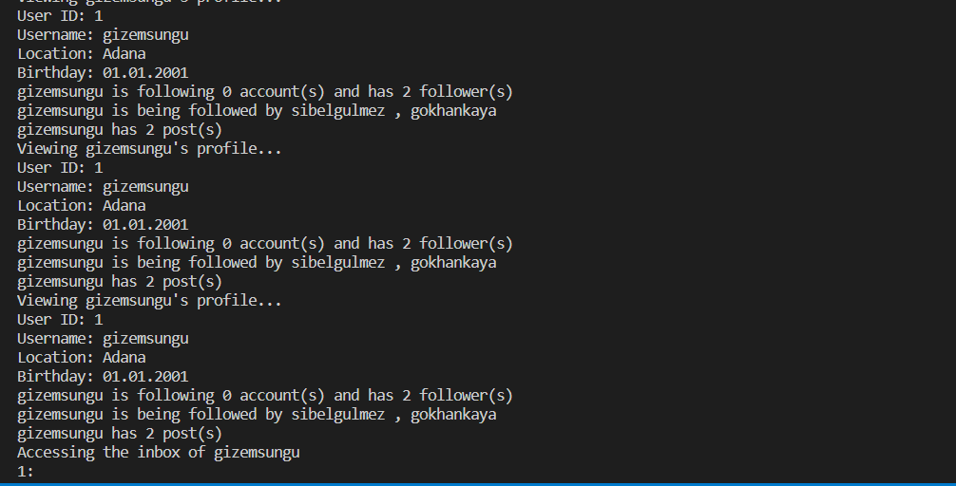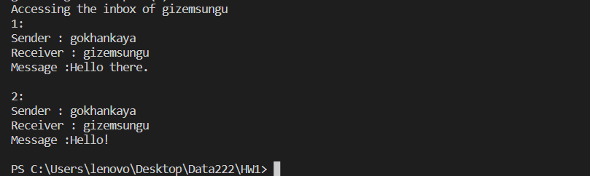

Test Case 3

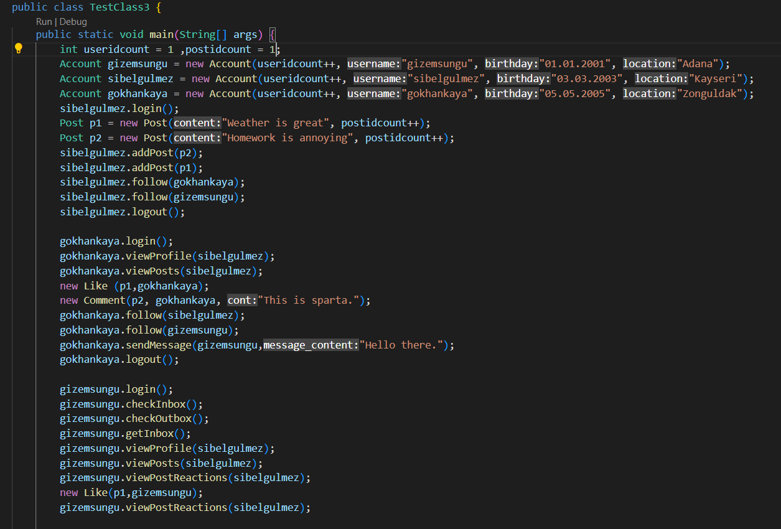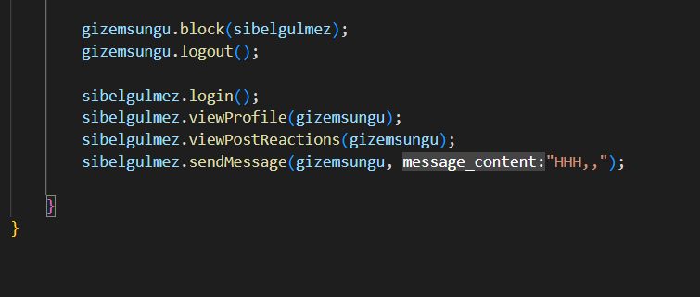

Result 3

